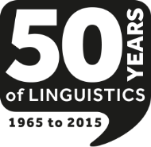
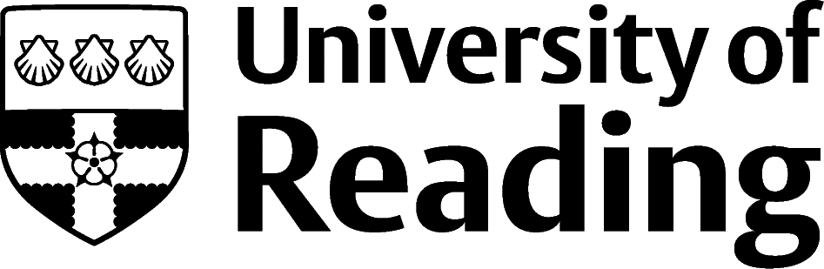

BAAL-Routledge Research Development Workshop 2015
Task-based L2 Fluency: definition, measurement and analysis

Place: University of Reading, UK Date: Thursday 15 October 2015
Institute of Education Time: 9.15am – 5pm
London Road, Reading
Building LO33, room 120

Contact details: Dr Clare Wright, Department of English Language and Applied Linguistics
Email: c.e.m.wright@reading.ac.uk

Researchers/ECRs/PhD students interested in L2 speech fluency and its development in different tasks/contexts are invited to this BAAL/Routledge-supported workshop to:
- Discuss current benchmarks of how to operationalise L2 fluency in tasks
- Understand challenges of methodologies for measuring different aspects on L2 fluency
- Have hands-on training in CLAN and PRAAT for transcribing and analysing L2 speech
- Present a poster-based summary of your own research

Our objective is to integrate fresh theoretical insights and methodological strengths from a range of paradigms, to ensure future comparability, replicability and reliability in applied linguistics oral research. The discussions, training and networking arising during this day are intended as a basis for a national interdisciplinary community of practice in L2 speech, linking PGR, ECR and more established research leaders.

Deadline for registration 12 October 2015
Numbers are limited to 25 – so book early to avoid disappointment
Workshop costs: £10 to cover costs of refreshments

Programme:
9.15 Welcome, and overview of issues in the field: Dr Tavakoli and Dr Wright, UoR
9.45 Training in PRAAT and CLAN (with break)
12.45 Lunch and posters
2.00 Surgery/hands-on sessions, facilitated by workshop organisers
3.45 Evaluation and discussion of core areas for future fluency research
4.45 Next steps to set up “SLA Research Forum for Fluency Research” network (Finish 5pm)

To book your place, email: c.e.m.wright@reading.ac.uk
For travel to London Road campus, see our university maps here: Reading Maps
Please notify us of your affiliation, stage of research; also any dietary requirements or needing a parking permit

POSTERS: Any researcher wishing to bring a poster should bring this in a format that can be easily put up in the workshop computer lab; ideally no larger than A3 for ease of display (black & white or colour); brief synopsis of your research questions, methodology, any results if you have them (blutak provided).

Co-ordinators: Dr Clare Wright, Dr Parvaneh Tavakoli, Dr Louise Courtney, Prof Jeanine Treffers-Daller, University of Reading; Ann-Marie Hunter, University of St Mary’s Twickenham

