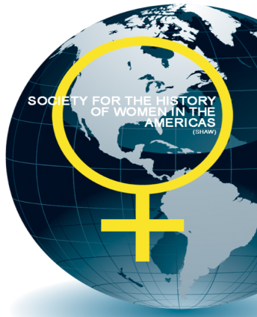
Society for the History of Women in the Americas Annual Conference

Friday 5th July 2019
University of Reading

The Society for the History of Women in the Americas (SHAW) welcomes proposals for its annual conference, co-organised with the Department of History at the University of Reading.

This year marks 100 years since the US Congress passed the proposed 19th Amendment, sent to states and then ratified in 1920. It also marks 150 years since the Wyoming Constitution gave women the right to vote in 1869.

So, we encourage proposals for papers, panels or roundtables that engage with the themes of women and citizenship and women’s relationship with, and resistance to, the state. We also welcome proposals that engage with ideas about women’s legal personhood, how we think about womanhood, practices of protests, and that encourage us to think beyond binaries. More broadly, we will consider proposals on any theme related to the history of women in the Americas.

The conference welcomes proposals from academics at any stage of their career, especially graduate students, as well as those active in civil society groups.

The keynote lecture will be delivered by Professor Barbara Savage, University of Pennsylvania and Harmsworth Visiting Professor of American History, Rothermere American Institute at the University of Oxford, 2018-19.

We invite 250 word abstracts for papers of 20 minutes length. For full panels and roundtable discussions, please include descriptions of all papers proposed.

Please submit abstracts along with a 100-word biography of each proposed speaker to shawsociety@gmail.com, by 29th March 2019. Papers chosen for the conference may be selected for inclusion in a special issue of History of Women in the Americas journal subject to peer review.

Financial support for the conference is provided by the University of Reading’s Diversity and Inclusion Fund, and the British Association for American Studies (BAAS).

