FRIENDS OF THE LANDSCAPE LIBRARY AND ARCHIVE AT READING (FOLAR)

AGM/ Annual Seminar at MERL, University of Reading Saturday 1 April 2017, 10am to 4pm.
Existing and new members welcome the AGM and Seminar is also open to non members

Landscape Architecture and Management Education in the UK: past present and future

This year’s FOLAR Seminar deals with the origins and history of landscape architecture and management education in the UK, past, present and the future. Speakers will include Guy Baxter, the University of Reading Archivist, on the history of the first landscape architecture course in the UK, that at Reading (1930-1959). Then Jan Woudstra will survey the origins and growth of landscape courses nationally. Richard Bisgrove will outline the story of the BSc Landscape Management at Reading (1986-2010). Finally Robert Holden (formerly University of Greenwich) will review current trends, speculate about the future and in particular look to the past to see lessons that can be applied today. Our chair will be John StuartMurray of the University of Edinburgh.

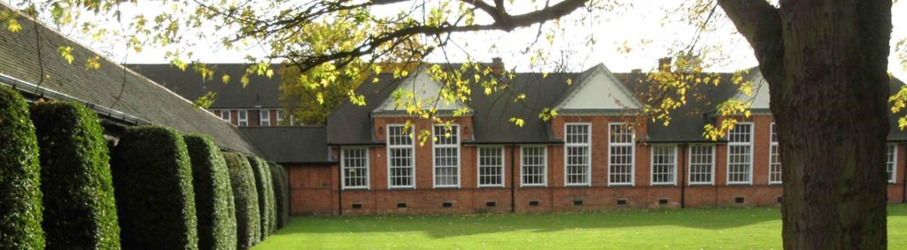
Our AGM is from 10.30am-12.00pm, and all (members and non members) are welcome from 10am onwards, lunch will 12-12.30pm and the afternoon seminar will run from 12.30pm-4pm. Duplicate books from the LI collection will be on sale.

Cost: for FOLAR members £15 incl. lunch (a £35 payment on the day would include FOLAR membership renewal).
For non members the cost of the seminar incl. lunch is £25.

PLEASE BOOK EARLY FOR THIS EVENT as we have a limit on numbers – 50 maximum.

Location of FOLAR AGM/Study Day & Exhibition: MERL (Museum of English Rural Life), Redlands Road, Reading, RG1 5EX

Map: https://www.reading.ac.uk/themerl/visit

FRIENDS OF THE LANDSCAPE LIBRARY AND ARCHIVE AT READING (FOLAR)

AGM/ Annual Seminar at MERL, University of Reading Saturday 1 April 2017, 10am to 4pm.

Booking Form

Name: …………………………………………………………………………………………………………………….

email: ………………………………………………………………………………………………………………………

Postal address: ……………………………………………………………………………………………………….

..……………………………………………………………………………………………………….

I will be attending (please tick as appropriate):

AGM (no charge)

Afternoon seminar Members rate* (including lunch) £15

Non members rate* (incl lunch) £25

I would like to join FOLAR and enclose my membership fee of £20
New members joining via this form will be eligible for the lower, members, seminar booking fee

I would like to renew my membership and enclose my membership fee of £20

Payment:
Please email me an invoice with details for electronic payment

I will send a cheque to The Treasurer, FOLAR, c/o Land Management Services, Redhill Chambers,
2D High Street, Redhill, RH1 1RJ (please indicate if you require a receipt – available for collection at the Seminar)

The seminar is limited to 50 delegates; seats can only be confirmed on receipt of payment

The membership year runs from May 2016 to May 2017

email: info@folar.uk

