Creating a SNS profile for an internship?
Maisy is a hard working student, who is involved in campus volunteering initiatives such as mentoring local school children. She has been very involved with her sports club, and does shifts at Nightline, the student run telephone support service. As a second year, she is looking to do a year in industry to top up the funds and add extra weight to her CV.
Maisy has never had time to get involved with social networks on the Internet, preferring the immediacy and dynamic nature of face-to-face conversations. She uses email and, occasionally, gets distracted by her instant messenger program when she is trying to study, but apart from that, the Internet is chiefly a resource for researching things – whether they are academic or about fashion.
One of the companies Maisy would like to work for, though, has a strong presence in one of the social networks, and has been contacting people though this medium about their plans for a year in industry. Maisy is not sure whether she wants to get involved in this – on the one hand, she could sit down and write a profile to provide an online presence, but on the other hand, she has plenty to do, with a busy second year at university.
What is worse is that she cannot work out whether a plain and straightforward profile would actually help her in this case. It may be that it would look just a bit too ‘engineered’ and put a potential employer off. Some people expect to see a ‘back story’ behind an online persona, and it may just be too late to create one now.

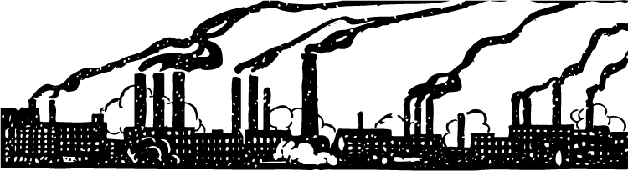
Worksheet 6
Context:
You are a second year student interested in an industrial placement. You have avoided being drawn in to social networking sites, preferring to spend time with your friends. You have three companies that offer interesting opportunities for a year out, and you discover from one of your friends that two of them have been getting in touch with potential interns through Facebook. While you were chatting with friends over coffee, you heard that there are 20 people applying for each position within the companies, so it is going to be quite competitive.

- What basic research would you do to try to determine whether you are more likely to be successful in your application if you have a Facebook profile?
__________________________________________________________________________________________________________________________________________________________________________________________________________________________________________________________________________________________________________________________________________________________________________________________________________________________
- If you choose to create a profile, for the purposes of enabling the companies to find you, what sort of information would you make available?
__________________________________________________________________________________________________________________________________________________________________________________________________________________________________________________________________________________________________________________________________________________________________________________________________________________________
- What do you think it says about you, if you just create the profile with your academic achievements and areas of professional interests?
__________________________________________________________________________________________________________________________________________________________________________________________________________________________________________________________________________________________________________________________________________________________________________________________________________________________
- If you were interacting with potential employees via a social networking site, how would you see someone who had created a profile just to interact with you, or to get your attention?
__________________________________________________________________________________________________________________________________________________________________________________________________________________________________________________________________________________________________________________________________________________________________________________________________________________________

Image by Johnny_automatic in public domain available at http://openclipart.org/media/files/johnny_automatic/3883

