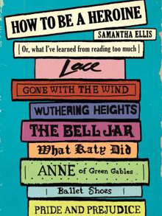
Come to a talk & book-signing by
Samantha Ellis
for her best-selling book
How to be a Heroine
Or, What I Learned from Reading Too Much
Wednesday, March 12th, 5-6pm, HUMSS G27

