Twittering
In the ‘old days’ people used forums and bulletin boards to have conversations amongst communities. Email can also be used for one-to-one, one-to-many and many-to-many communications, but quickly becomes hard to follow different threads of conversation. Social networking sites opened up ways of having a many-to-many communication via people’s walls (in Facebook) and through use of groups – but Twitter popularised the idea of micro-blogging what you are doing or thinking to the whole world.
People who use it (‘Tweeple’) were quick to come up with ways of holding semi-private conversations (addressing a remark @someone) which anyone can see. It also has a means of sending ‘Direct’ (or private) messages to others.
Chas started using Twitter to communicate with some of his friends. Because he liked to chat about books, he occasionally gained a few other ‘followers’ – people who were interested in his status updates. Although Chas still feels that it is a little odd that people from around the world are interested in what he has to say, he continues to update the ‘Twitterverse’ with comments on books he has read, interspersed with occasional conversations with friends, total strangers, and the odd Tweet about his day to day life.
Chas was a little surprised when his Mum signed up to Twitter, and spent a little time wondering whether he should protect his updates. Protecting them means that people can’t read what he writes unless he gives them permission. However, in the end, he decided that although he had made some comments about books that he would have phrased differently if he had intended his Mum to read them, she is a tolerant sort of person and probably wouldn’t be bothered to read through his entire history of Tweets. Chas’ partner, Sam, however was little concerned that some of their Twitter conversation could be seen by ‘the mother-in-law’ and decided to protect their updates.
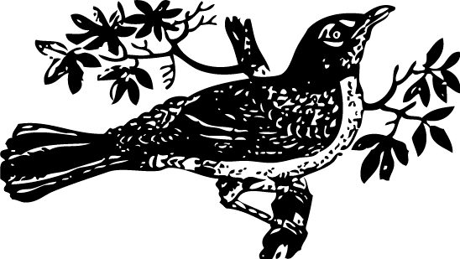

Worksheet 2
Context:
You are an undergraduate student and you start using Twitter over a summer vacation as it was used by staff at the small company at which you had an internship. When you are back at university, you find that a number of others are also using it.
- Thinking about these people
Ali - who takes the same modules as you
Bob - who takes one module with you
Cat - doing the same degree course as you but in a different name
Doug - a postgrad who helps with one of your tutorials
Ed - a lecturer on one of your module
Fi - your personal tutor
Greg - your student union president
Hiya - your student radio's twitter id
Mum - your mother
VC - your university's senior manager
X - your ex-lover
  - Which would you choose to follow and why?
______________________________________________________________________________________________________________________________________________________________________________________________________________________________________________________
  - What would be your reaction if any of the above started following you?
______________________________________________________________________________________________________________________________________________________________________________________________________________________________________________________
  - Would you expect the above to follow you if you followed them?
______________________________________________________________________________________________________________________________________________________________________________________________________________________________________________________
- How would you feel when a stranger from the other side of the world ‘follows’ you
  - If they seem to have similar interests?
______________________________________________________________________________________________________________________________________________________________________________________________________________________________________________________
  - If they appear to Tweet about completely different things?
______________________________________________________________________________________________________________________________________________________________________________________________________________________________________________________

- Now would you Tweet about
  - Your social life?
______________________________________________________________________________________________________________________________________________________________________________________________________________________________________________________
  - Your love life?
______________________________________________________________________________________________________________________________________________________________________________________________________________________________________________________
  - Your academic life?
______________________________________________________________________________________________________________________________________________________________________________________________________________________________________________________
- Where will you Tweet from
  - The pub?
______________________________________________________________________________________________________________________________________________________________________________________________________________________________________________________
  - The classroom?
______________________________________________________________________________________________________________________________________________________________________________________________________________________________________________________
  - The supermarket queue?
______________________________________________________________________________________________________________________________________________________________________________________________________________________________________________________
  - The library?
______________________________________________________________________________________________________________________________________________________________________________________________________________________________________________________
  - Your room?
______________________________________________________________________________________________________________________________________________________________________________________________________________________________________________________

Image by Johnny_automatic in public domain from http://openclipart.org/media/files/johnny_automatic/3253

